Assessing the Gap: Current Market vs. Assessed Value
Nate Cramer - Bureau of Local Assessment Certification Advisor
As a homeowner, how many times have you tried to compare your assessed value to what you think it might sell for? How many times have you wondered why your local assessor valued your property for an amount greater or less than what your neighbor’s house recently sold for? The assessed value on your tax bill can be misinterpreted because it is based on market activity from the previous year.
The effective date of your assessed value is the January 1st prior to the fiscal year. For example, the assessment date for FY2018 (which began July 1, 2017) is January 1, 2017, and the market analysis, or comparable sales to be analyzed, examines those that occurred in calendar year 2016 (January 1, 2016 through December 31, 2016). So it is possible the sales used to determine your assessed value are up to 18 months old by the time you receive a bill. This can be confusing even for the professionals who do this work every day. The chart below may help readers understand the timelines more clearly:
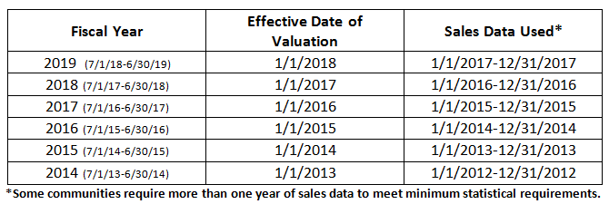
As you can see, the transactions occurring right now (calendar year 2017) will not be reflected in your property tax bill until Fiscal Year 2019.
Per M.G.L. Chapter 40, sec. 56, real estate is to be assessed at full and fair cash value, often referred to as market value. If a community’s assessments are not equitable and consistent, its values will not be certified by the Bureau of Local Assessment, which could hold up the tax rate setting process.
There are two primary statistical measures used to determine the accuracy and uniformity of assessed values in any given community. One is the assessment to sale ratio (ASR), which measures how closely the assessed value reflects the market (assessed value/sale price = ASR). This is performed on every transaction. Each year, assessors calculate a median ASR for each class of property in town. The median is the middle point of a number set, in which half the numbers are above the median and half are below. In Massachusetts, the median ASR of the predominant class in a community is required to fall between 90%-110% of fair cash value. For a majority of communities, single-family homes are the predominant class. For every other class of real property, such as condominiums, multifamily units, vacant land, etc., the median ASRs must then fall within 5% of the community’s predominant class.
The second statistical measure is the coefficient of dispersion (COD), which measures the uniformity of the assessments among properties in the community. The COD is the ratio of the average deviation of a group of numbers from the median. A COD statistic of 10% or less would indicate a high level of uniformity. In Massachusetts, assessors are required to have a COD of 10% or less for single-family homes in order for their values to be certified by BLA. A higher COD is allowed for other types of properties, such as commercial and industrial, which typically do not have as much sales data available as single-family homes.
It is important to note that in performing this analysis, only arm’s length transactions are considered. An arm’s length transaction is a sale between a willing buyer and a willing seller with no unusual circumstances involved in the sale. Examples of non-arm’s-length transactions include sales between family members, estate sales and foreclosure sales. These are automatically culled from the assessor’s analysis.
As mentioned earlier, single-family homes represent the predominant class in the vast majority of Massachusetts communities. The following two tables compare median ASRs by county for the last four fiscal years based on arm’s length sales data contained in the DLS Gateway application.
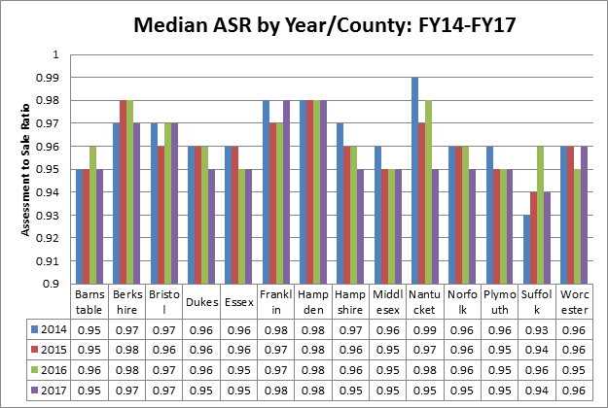
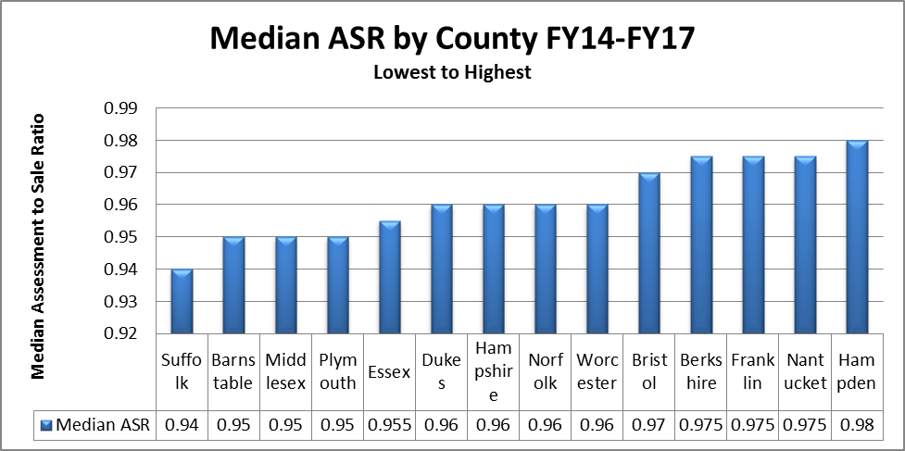
As you can see, the median ASR over the past few years never reached 100% in any county. Most communities prefer to keep their ASRs around 95%, which is well within the 90%-110% requirement. In fact, the median ASR of all arm’s length transaction statewide over these four years was 96.1%. Why do assessors tend to keep their medians below 100%? Put simply, it is because a median of 100% indicates that half of the properties in the community are valued over 100% of market value. Assessors are well aware that the market fluctuates, and therefore, keeping values slightly below 100% creates a cushion should there be sudden market changes. Additionally, if half the properties in a community were assessed at over 100%, (e.g. sale price of $400,000 with an assessed value of $420,000), there would be an increase in abatement applications, which puts stress on your local assessor’s productivity and risks the loss of anticipated revenue.
Below is a real life example of a home that sold three times since 2006, to illustrate how a fluctuating market can affect a property’s assessed value. This is an excellent example because it shows the value before the 2008 market crash, the value at the low point as a result of the crash, and the present value. Take a look at the ASR for each of those sales. While the FY2011 value was still within guidelines, I would guess that this taxpayer had a few questions for the local assessor:
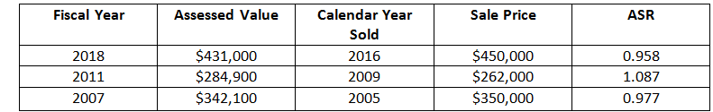
Have you recently purchased or refinanced a property? Unless you are in a stagnant market your assessment and your current appraised value will almost never be the same. It is important to understand the lag time between your assessed value and current market value. If you feel your home is overvalued by the assessor and you decide to hire an appraiser to contest the value, you would need a retrospective appraisal, which uses comparable sales that occurred during the same time period the assessor used to determine your assessed value (refer back to chart in beginning of article). It’s important to remember that this is mass appraisal. Assessors do not appraise every house individually, but rather hundreds or thousands at a time, using tables based on market data. The assessors’ valuations will only be as good as their data, which is why it is so important for communities to continually review building permit data and perform inspections. Even then, there will certainly be outliers.
I am sure at this point, armed with all of this new knowledge, you must be wondering what the median ASR and COD is in your town. Unfortunately, we do not store CODs in our databases, but rest assured, communities’ values will not be certified if they do not conform to the Commissioner’s guidelines. Keep in mind that there are communities where the predominant class is not single-family dwellings, and being less reliant on that class, they may keep their median ASRs slightly lower. On the other hand, a community with a higher median ASR might indicate more reliance on the single-family class.
If you want to see your community’s median ASR from FY14-FY17, click here. If you are interested in learning more about the guidelines local assessors are required to follow, click here.
Hopefully, this article has shed some light on what seems to be a constant topic of conversation when friends and family of those in this field receive their new valuations every year.

