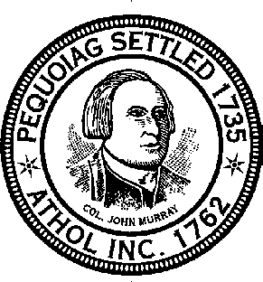
Athol Board of Health
978-721-8450

2023 Athol Trash Hauler List
Business Name | Address | Town/Zip | Services | Phone
Bill's Rubbish | 2068 S. Athol Road | Athol, MA 01331 | 1,4 | 978-249-4929
UMM Hauling Inc. | 331 A SW Cutoff | Millbury, MA. 01527 | 5 | 508-203-6449
D & D Waste Removal | 72 Jackson Avenue | Fitchburg, MA 01420 | 2,3,5 | 978-342-6893/978-549-6655*
Ken’s Rubbish Removal | 111 Lee St. | Athol, MA 01331 | 1 | 978-413-2764
G.L.M., Inc. | PO Box 221 | Orange, MA 01364 | 1,2,3,4,5 | 978-544-6511*
Griff's Rubbish Removal | 657 Pleasant Street | Athol, MA 01331 | 1,2,3,4,5 | 978-249-6468*
Northeast Recycling, LLc | 155 Bodwell St. | Avon, MA. 02322 | ` | 781-436-5857
Kary Chiasson | 352 Harvard Avenue | Athol, MA 01331 | 1,2,3,4 | 978-249-9093*
E.L.Harvey & Sons, Inc. | 68 Hopkinton road | Westboro, MA. 01581 | 1,5 | 508-836-3000
KK's Roll Offs | 2739 Old Keene Rd | Athol, MA 01331 | 3,5 | 978-248-9894/978-944-3004*
Larry's Rubbish Removal | 90 Mattawa Circle | Orange, MA 01364 | 1,2,3,4 | 978-544-8926*
LeBlanc Enterprises | 445 Cottage Street | Athol, MA 01331 | 1,2,3,4, | 978-249-4061
Mallett Rubbish & Recycling | PO Box 12 | Athol, MA 01331 | 1,2,3,4,5 | 978-249-9662
Monadnock Disposal Service, Inc | 101 Old Sharon Road | Jaffrey, NH 03452 | 1,2,3,4,5 | 603-532-8088*
Pioneer Valley Disposal | 112 Sandrah Drive | Orange, MA 01364 | 1,2,3,4 | 978-544-8015*/978-821-0836
Republic Services | 845 Burnett Road | Chicopee, MA 01020 | 1,4,5 | 413-557-6700
Waste Management of Massachusetts,Inc | 124 Hartwell Street | W. Boylston, MA. 01583 | 4,5 | 1-800-545-4560*/774-261-2910
Legend:
1 - Weekly Residential Pickup |  | *Emergency 24 Hour Number
2 - One Time Residential Pickup
3 - Cleanouts
4 - Commercial Pickup
5 - Dumpster/Roll-offs

