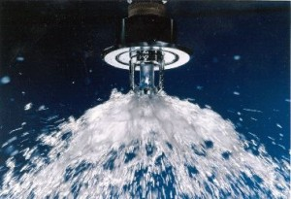

Fire Sprinkler line owners must notify the Athol Water Department at a minimum, 24 hours in advance of any fire sprinkler work being done on your system at 978-721-8448 or 978-249-9244. The owner is also responsible to contact the fire sprinkler company and to notify the Fire Department. The Water Department is notifying all Fire Sprinkler companies of this requirement. There are a couple of reasons for this.

- The first reason is that there is a potential drop in pressure in the water system when water is flowing through your sprinkler system which triggers alarms at our facilities indicating a possibility of a water main break.
- The second reason is the potential for discolored water in other areas of town due to the pressure drop causing hardships for restaurant owners, consumers doing laundry, etc.. When residents call into the office, personnel will be able to give an explanation as to the reason.
- The third reason is that we are required by EPA and DEP to account for all water pumped from our water sources annually and to be within 10% of water metered and accounted for. We need an estimate of water flowed from your work/test to include in our calculations to avoid more costly requirements placed on the Water Department.

We appreciate your anticipated cooperation in this matter. If you have any questions, please feel free to contact Richard P. Kilhart at the main office at 978-721-8448.

Thank you,
THE ATHOL PUBLIC WORKS – WATER DIVISION

