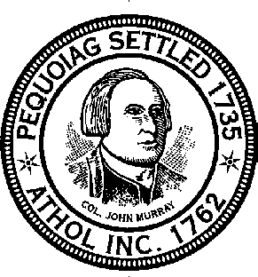
Town of Athol
Board of Health
584 Main Street Athol, Massachusetts 01331
978-249-7934

2023 Application for Trash Hauler Permit
Fee: $150.00 Annually Payable to the Town of Athol

Pursuant to Massachusetts General Law Chapter 111, section 31A.
Date of Application:
Name of Applicant:
Business Name: Click here to enter text.
Business Address:
Mailing Address: Same
Telephone Number: 24 Hour Emergency Number:
Email Address:
Type of Services offered, please check all that apply:
1. Weekly Residential Pickup 3. Cleanouts X 5. Dumpsters or Roll offs
2. One Time Residential Pickups 4. Commercial Pickup

Site of Disposal Information:
Name, address and telephone number of facility, or facilities, (landfill, incinerator, etc.) which will be used
to dispose of refuse and recyclables collected in Athol:

Vehicle Information:
Each vehicle requires a separate permit sticker. Please attach separate sheet if more than 3 used.

Description of Vehicle (make, model, color) License Plate #
___

___________________________________________________________________________________
Description of Vehicle (make, model, color) License Plate #

______________________________________________________________
Description of Vehicle (make, model, color) License Plate #

New applicants only:
Please provide three (3) References; include name, address, and telephone number for each.

Pursuant to MGL C 62C, S 49A, I certify under the penalties of perjury that I, to the best knowledge and belief, have filed all State Tax returns and paid all State Taxes required under law.

______________________________________________________________________________________
Signature Title

Federal ID #:___________________________

