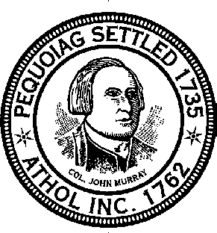
Town of Athol
Board of Health
584 Main Street Athol, Massachusetts 01331
978-721-8450

Residential Kitchen Application
FEE: $75.00 Payable to “Town of Athol”

Date of application:
Name:
Address:
Telephone Number: Email:

Business Details:

Business Name:

Distribution: _____ __ Retail _____Wholesale

Selling Product from: _______ Home _____ Farmer’s Market _____Other:
________________

Water Source: _______ Town ___ __Private Well
If well water is used, test results for quality must be submitted with application and will be required annually with renewal.

Food Item Details:

Please attach the following information to this application:
- Foods being prepared
- Ingredient list of each food prepared
- Purchasing source of ingredients
- Methods of preparation

Your application will not be processed without this information.

Requirements:
Only non-potentially hazardous foods (Non-PHF, meaning no time/temperature controls required) and foods which do not require refrigeration shall be prepared in or distributed from a residential kitchen. Only immediate family members may assist in preparation and distribution. Pets may not be present during food preparation and laundry facilities (if located in kitchen) may not be used during food preparation. Food contact surfaces shall be smooth and made of non-absorbent materials. All foods sold shall be labeled, to include ingredients (by order of volume), allergen and health claims. A food establishment permit will be required for food preparation and distribution from a residential kitchen for retail sale and shall comply with minimum requirements of 105 CMR 590.002 through 105 CMR 90.009, as well as administrative enforcements of 105 CMR 590.012 through 105 CMR 590.021.
*Please note: A residential kitchen permit does not allow consignment as a means of selling.

I hereby certify that I am familiar with 105 CMR 590.000, Minimum Sanitation Standards for Food Establishments – Article X, and that the residential kitchen will be operated and maintained in accordance with the regulations.

______________________________________________________ _________________________________
Signature Date

_______________________________________________________________________________________
This section is for Board of Health use only.

Permit Approval:

Permit number: ______________ Effective Date: ________________

Permit Restrictions:
________________________________________________________________________________________________________________________________________________________________________________
Effective Date of Permit: ___________________________________________________________________

Permit Denied: Effective Date: _________________

Reason for Denial:
________________________________________________________________________________________________________________________________________________________________________________

________________________________________________________________________________________
Reviewer’s Signature and Title Date

